Assessment task — Communities in colonial Australia (1800s): Sources

Source 1
A nation transformed
‘Australia attracted adventurers from all around the world. The majority of these new arrivals were British but also included Americans, French, Italian, German, Polish and Hungarian exiles. The largest foreign contingent on the goldfields was the 40 000 Chinese who made their way to Australia.’
‘In 1852 alone, 370 000 immigrants arrived in Australia … in just two years, the [Victorian] State’s population had grown from 77 000 to 540 000! ... The total population trebled from 430 000 in 1851 to 1.7 million in 1871.’
Source: Wells, Kathryn 2015, The Australian gold rush, Australian Government, http://www.australia.gov.au/about-australia/australian-story/austn-gold-rush CC BY 3.0 creativecommons.org/licenses/by/3.0/au/

Source 2  Zealous* gold diggers, Bendigo, by ST Gill, 1855  The gold rush to Bendigo started in 1851, and enthusiastic miners rushed to find their fortunes, as illustrated in this image.  *zealous: keen, enthusiastic, eager | Gill, ST 1855, Zealous gold diggers, Bendigo, National Library of Australia, nla.pic-an7518147, http://nla.gov.au/nla.pic-an7518147

Source 3  Canton Lead monument  Built to remember the Chinese miners who discovered gold in the area of Ararat in south-west Victoria in 1857. The area developed into a thriving gold town. It is the only city in Australia to have been founded by Chinese migrants.  Reference: Canton Lead [Monument Australia], http://monumentaustralia.org.au/themes/landscape/settlement/display/30069- | 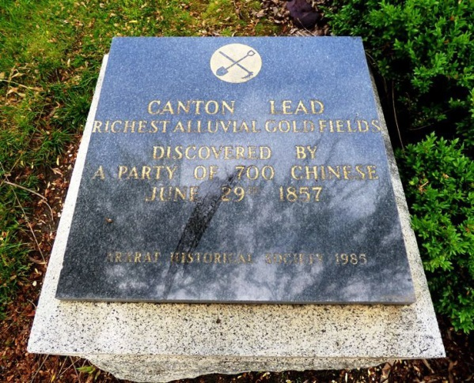  Source: Saunders, G 2014, Canton Lead Monument, Monument Australia, http://monumentaustralia.org.au/themes/landscape/settlement/  display/30069-canton-lead Used with permission.

Source 4
Observations of Ellen Clacy, a female digger at the Bendigo goldfields
‘There is more drinking and rioting at the diggings than elsewhere, the privacy and risk gives the obtaining it an excitement which the diggers enjoy as much as the spirit [alcohol] itself; and wherever grog is sold on the sly, it will sooner or later be the scene of a riot …’
Source: Clacy, E 1852–53, A lady’s visit to the gold diggings of Australia in 1852–53

Source 5
Observations of Ellen Clacy, a female digger at the Bendigo goldfields
‘The good people of Victoria were rather jealous of the importance given by these events [gold discoveries] to the other colony [New South Wales]. Committees were formed, and rewards were offered for the discovery of a goldfield in Victoria. The announcement of the Clunes Diggings in July, 1851, was the result; they were situated on a tributary of the Loddon [River]. On September 8, those of Ballarat, and on the 10th those of Mount Alexander, completely satisfied the most sceptical [doubtful] as to the vast mineral wealth of the colony. Bendigo soon was heard of; and gully after gully successively attracted the attention of the public by the display of their golden treasures.’
Source: Clacy, E 1853, A Lady’s Visit to the Gold Diggings of Australia in 1852–53.

Source 6
Development of towns at goldfields
Many towns developed on the site of mining camps during the gold rushes as businesses were set up to provided supplies and services to diggers. Many miners who had become wealthy from their finds established farms. Diggers spent their money in towns like Ballarat and Bendigo, and from this money, these towns could afford to create roads, build libraries and establish other necessary services.
This photograph shows Clark Street in the gold rush town of Hill End, NSW in 1872. At this time, there was an approximate population of around 8 000 people at Hill End. Over a short time, establishments were built throughout the town, including over one km of shops, two newspapers, five banks and 27 hotels. Hill End owes its existence to the gold rush period. | 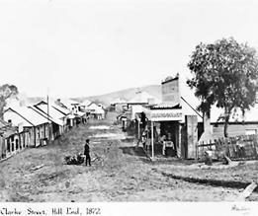  Image: Merlin, HB 1872, Street in Hill End, a gold rush town in New South Wales, National Archives of Australia, Item 11484720 http://recordsearch.naa.gov.au/SearchN  Retrieve/Interface/ViewImage.aspx?B=11484720

Source 7
Economic impacts of the Australian gold rushes
‘The gold bullion that was shipped to London each year brought a huge flow of imports. The goldfield towns also sparked a huge boost in business investment and stimulated the market for local produce. The economy was expanding and thriving.
Because so many people were travelling to and from the goldfields, the 1850s also saw the construction of the first railway [Victoria in 1854, NSW in 1855¹] and the operation of the first telegraphs [Victoria in 1854, Melbourne to Sydney 1858, Melbourne to Adelaide 1858²].’
Wells, Kathryn 2015 The Australian gold rush, The Australian Government, http://www.australia.gov.au/about-australia/australian-story/austn-gold-rush CC BY 3.0 AU creativecommons.org/licenses/by/3.0/au/
References:
1 History of Rail in Australia (Australian Government, Department of Infrastructure and Regional Development) https://infrastructure.gov.au/rail/trains/history.aspx
2 Thompson, D 2008 The Australian telegraph network 1854–1877 (Museum Victoria) http://collections.museumvictoria.com.au/articles/2625 Accessed 25 November 2015

Source 8
Effects on businesses and labour
At first, the rush to the goldfields resulted in labour shortages in both rural (farming) and urban (city) areas. Workers simply left their jobs to go to the gold diggings, leaving many business owners in financial difficulty; for example, farmers were left with unharvested crops, and fishing vessels had no fisherman. Wages increased to attract workers back to vital industries. Many migrants took up jobs that had been abandoned by those who had rushed to the diggings.
A third of the world’s gold produced during the 1850s came out of Victoria. The wealth produced brought imports and improvements to the Australian colonies. Diggers often spent their earnings in cities and towns. From such spending, cities like Melbourne developed better services to meet the needs of the growing population. Increases in the population also meant that local agricultural industries started to thrive because of the need to meet local demands.
References:
Scott, T Impact of gold on Australia (SBS Gold!), http://www.sbs.com.au/gold/story.php?storyid=70\
Australian Gold Rush (GoldOz, Australian Gold Shares, Mines and History) https://www.goldoz.com.au/australian-gold-rush/

